Ex.No: 1
CREATING A WEB PAGE USING IMAGE MAP
<html>
<head>
<img src="logo.jpg" align="left"><font size="20pt" color="blue"><B><center>WELCOME TO INDIA</center></B></font></head>
<hr size=4pt color="green">
<br>
<body>
<img src="India_map.jpg" usemap="#indiamap" align="left">
<map name="indiamap">
<area shape="circ" alt="chennai" coords="205,448,5" href="chennai.html">
<area shape="circ" alt="mumbai" coords="81,333,5" href="mumbai.html">
<area shape="circ" alt="kolkatta" coords="329,285,5" href="kolkatta.html">
<area shape="circ" alt="delhi" coords="153,178,5" href="delhi.html">
</map>
<p align="left">
<img src="tajmahal.jpg" align="right">
<h3> Facts and Figures: </h3><br>
<b>Name:</b> India
(long form) Republic of India <br>
<b>Population:</b> 1,080,264,400 <br><br>
Population & Density (all countries) here <br><br>
<b>Capital City:</b> New Delhi (10.8 million) <br>
<b>Currency:</b> Indian Rupee (INR) <br>
Currency Converter here <br><br>
<b>Languages:</b> Hindi, Bengali and 13 other (official) languages, including Telugu, Marathi, Tamil, Urdu, Gujarati,<br> Malayalam, Kannada, Oriya, Punjabi, Assamese, Kashmiri, Sindhi, and Sanskrit. Hindustani is widely spoken in the north, and English is, for the most part, the language of modern business. <br><br>
<b>Flag:</b> &nbsp;&nbsp <img src="insmall.gif"><br><br>
<b>National Day:</b> January 26 <br><br>
<b>Religions:</b> Hindu (80%), Muslim (13%), others <br>
</p>
</body>
</html>

Chennai.html
<html>
<head><center><font color="blue" size="25pt">SINGARA CHENNAI</font></center></head>
<hr size=5pt color="green">
<img src="chennai.gif">
<img src="vic.jpg" >
<img src="par.jpg" >
<img src="spencer.jpg">
<img src="marina.jpg">
</head>
<body>
<font color="red" size="5pt">
<ul type="circle">
<li>Chennai is the major city in India</li>
<li>It is the capital of TamilNadu</li>
<li>Marina Beach - Asia's No:1 Largest Beach</li>
<li>Good city for better Education</li>
</ul>
</font>
<a href="map.html"> Go to view India Map</a>
</body>
</html>
delhi.html
<html>
<head><center><font color="blue" size="25pt">DELHI</font></center></head>
<hr size=5pt color="green">
<img src="delhi-map.jpg">
</head>
<body>
<font color="red" size="5pt">
<br>
Delhi or National Capital Territory of Delhi is India's capital and includes New Delhi, Old Delhi, and Delhi Cantt. Also referred to as NCR, it incorporates satellite cities of Faridabad, Gurgaon, Ghaziabad and Noida.<br><br>
Delhi has always been an attraction for travelers and tourists. It caters to various needs of tourists.<br><br>
From shopping to sight seeing, forts and monuments to beautiful gardens, Delhi has it all. It also has many state of the art hotels to offer to its tourists.<br><br>
The economy of the state benefits from its service sector, which comprises of Insurance, travel and tourism, Mortgage, real Estate, consultancy and educational Institutes.<br><br>
A direct consequence of Delhi's rich history is its magnificent monuments. Delhi also offers a glimpse of India's religious diversity. <br><br>
It has many temples, mosques, gurudawaras and churches. No doubt that it is called the 'Heart of India'. <br><br>
</font>
<a href="map.html"> Go to view India Map</a>
</body>
</html>
Mumbai.html
<html>
<head><center><font color="blue" size="25pt">HOTEST MUMBAI</font></center></head>
<hr size=5pt color="green">
<img src="mumbai.gif">
</head>
<body>
<font color="red" size="5pt">
<br>
Mumbai is the seat of Bollywood cinema, shopping mall, bhelpuri on the beach, red double-decker buses and huge traffic jams. Mumbai is the commercial capital of India. <br><br>
The best time to visit Mumbai is between the months of September and April. The weather is then relatively dry and cool. From June to September there is immense shower, very often with fearsome results. We all know that the floods of 2005 took about a thousand and made thousands more homeless. You should also try to avoid the months just before the monsoon sets in, for then the temperature can be as high as 140º F. <br><br>
Mumbai is a place where people from different parts of India come for various purposes like trade and commerce, education, business and so on. It is a dream city for many people. The cost of living is very high in Mumbai. Big industrialists find Mumbai to be their ideal place for business. This city being located in close vicinity of Pune, is also visited by a large number of college goers and students from Pune. <br><br>
</font>
<a href="mumbai-map.jpg">View Mumbai Site-map</a><br><br>
<a href="map.html"> Go to view India Map</a>
</body>
</html>
kolkatta.html
<html>
<head><center><font color="blue" size="25pt">KOLKATTA</font></center></head>
<hr size=5pt color="green">
<img src="kolkata-map.jpg">
</head>
<body>
<font color="red" size="5pt">
<br>
Kolkata, formerly known as Calcutta, is the capital of West Bengal. It is located in eastern India on the east bank of the River Hooghly and has a subtropical climate. The city has many names: "Cultural Capital of India", "The city of Processions, "City of Joy" and so on. It has also been a home to many luminaries such as Rabindranath Tagore, Subhash Chandra Bose, Mother Teresa and Satyajit Ray. <br><br>
Public Transport in Kolkata is provided by Trams, Kolkata Metro and buses. Auto Rickshaws, Cycle Rickshaws and taxis are some other common modes of transport. For long distance travel, Kolkata has two railway stations, Howrah Station and Sealdah and one airport, Netaji Subhash Chandra Bose International airport at Dum Dum. <br><br>
</font>
<a href="map.html"> Go to view India Map</a>
</body>
</html>
OUTPUT
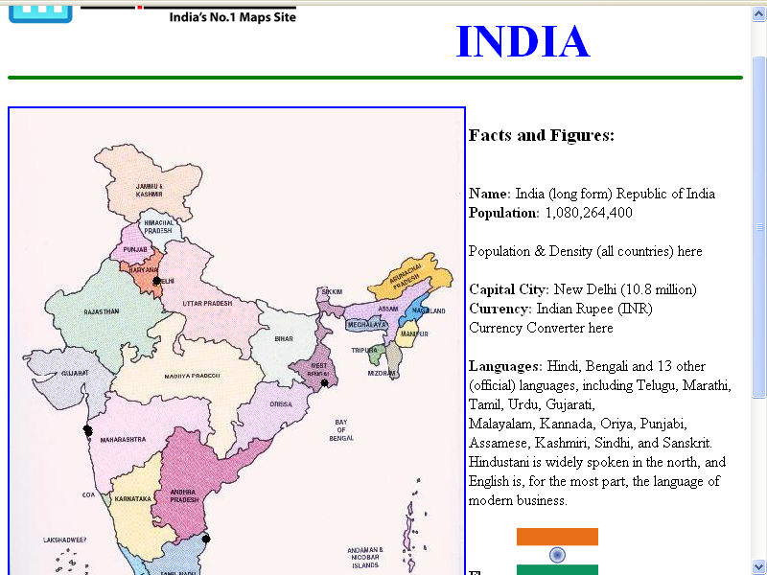

Ex.No:2
Creation of Web Pages using Cascading Style Sheets
Main.html:
<html>
<head>
<title>create web page for different types of style sheets></title>
</head>
<body bgcolor="#ffffff">
<p>
<font face = "arial" size = "5" color = "blue">
<br>
<center> <h1> main menu </h1> </center>
<hr>
<br>
<a href = " cascading.html"> 1.embeded or cascading style sheet </a> <br> <br>
<a href = " linked.html"> 2.external or linked style sheet </a> <br> <br>
<a href = "inline.html"> 3.inline style sheet </a><br> <br>
<br><br><hr>
</font>
</p>
</body>
</html>
Cascading.html:
<html>
<head>
<title>Embedded Style Sheet</title>
<style type = "text/css">
h1 {color:red; font-size:3em; font-family:Arial}
h2 {color:blue; font-size:2em; font-family:Helvetica}
h3 {font-style:Italic; font-weight:bold; color:green; font-size:2em}
h4 {text-align:center}
ul {list-style-type:disc; font-size:1em; color:brown; font-weight:bold}
</style>
</head>
<body bgcolor="#FFFFFF">
<p>
<h4><h1> Panimalar institute of technology </h1> </h4>
<h4> <h2> Nasarethpet, Poonamallee </h2> </h4>
<h4> <h3> Chennai - 600 123 </h3> </h4>
<hr>
<h3> No. of Courses Offered </h3>
<ul>
<li> IT </li>
<li> CSE </li>
<li> ECE </li>
</ul>
<hr>
<h4> <h3> <a href = "main.html" > Back to Main Menu </a> </h3> </h4>
</p>
</body>
</html>
style.css:
h1 {color:red; font-weight:bold}
h2 {color:blue; font-size:2em; font-family:Helvetica}
h3 {font-style:Italic; font-weight:bold; color:red; font-size:2em}
h4 {text-align:center}
ul {list-style-type:disc; font-size:1em; color:brown; font-weight:bold}
h5 {color:brown; font-size:3em}
Linked.html:
<head>
<title>Embedded Style Sheet></title>
<link rel = “style sheet” href = "style.css" type = "text/css">
</head>
<body bgcolor="#FFFFFF" >
<p>
<h4><h1> Panimalar Institute of technology </h1> </h4>
<h4> <h2> Nasarethpet, Poonamallee </h2> </h4>
<h4> <h3> Chennai - 600 123 </h3> </h4>
<hr>
<h3> No. of Courses Offered </h3>
<ul>
<li> IT </li>
<li> CSE </li>
<li> ECE </li>
</ul>
<hr>
<h4> <h3> <a href = "main.html" > Back to Main Menu </a> </h3> </h4>
</p>
</body>
</html>
Inline.html:
<html>
<head>
<title>Inline Style Sheet></title>
</head>
<body bgcolor="#FFFFFF">
<p>
<h1 style ="color:red;font-size:3em;font-family:Arial;text-align=center">
<h4> <h1> Panimalar Institute oftechnolofy</h1> </h4>
<h2 style ="color:blue;font-size:2em;font-family:Helvetica"/>
<h4> <h2> Nasarethpet, Poonamallee </h2> </h4>
<h4> <h3> Chennai - 600 123 </h3> </h4>
<hr>
<h3> No. of Courses Offered </h3>
<ul style = "list-style-type:disc;color:brown; font-weight:bold">
<ul>
<li> IT </li>
<li> CSE </li>
<li> ECE </li>
</ul>
<hr>
<h1> <h3> <a href = "main.html" > Back to Main Menu </a> </h3> </h1>
</p>
</body>
</html>

SAMPLE OUTPUT:

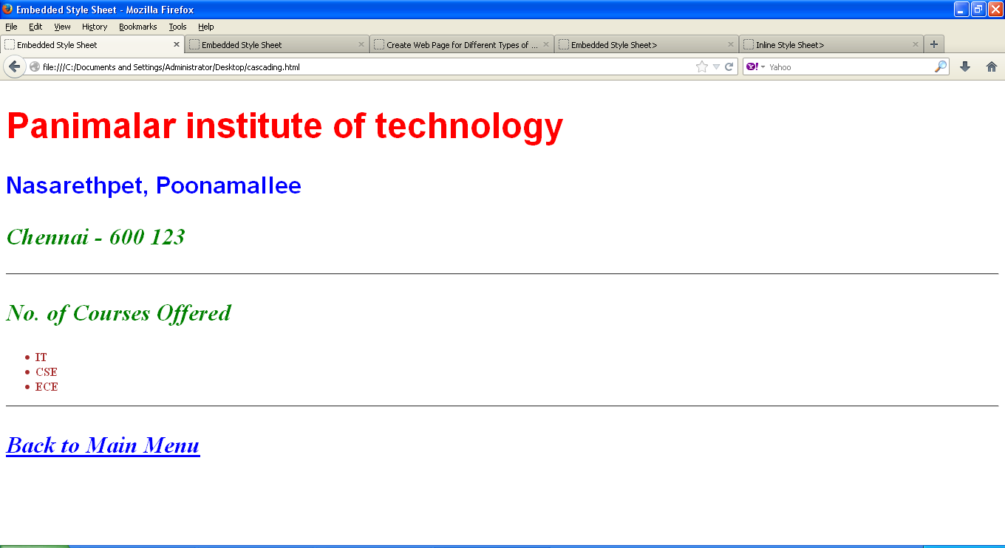

Ex.No: 3

PAGE VALIDATION USING JAVASCRIPT

<html>
<head>
<title>JavaScript Form validation</title>
<script>
// DEFINING A FUNCTION TO VALIDATE FORM
function validateForm()
{
var v_name = v_email = v_mobile = v_country = v_gender = false;
// Retrieving the values of form elements
var name = document.contactForm.name.value;
var email = document.contactForm.email.value;
var mobile = document.contactForm.mobile.value;
var country = document.contactForm.country.value;
var gender = document.contactForm.gender.value;
var hobbies = [];
var checkboxes = document.getElementsByName("hobbies[]");
for(var i=0; i < checkboxes.length; i++)
{
if(checkboxes[i].checked)
{
// Populate hobbies array with selected values
hobbies.push(checkboxes[i].value);
}
}

// Validate name
if(name == "")
{
alert("Please enter your name");
document.contactForm.name.focus();
}
else
{
var regex = /^[a-zA-Z\s]+$/;
if(regex.test(name) === false)
{
alert("Please enter a valid name");
document.contactForm.name.focus();
}
else
{
v_name=true;
}
}
// Validate email address
if(email == "")
{
alert("Please enter your email address");
document.contactForm.email.focus();
}
else
{
// Regular expression for basic email validation
var regex = /^\S+@\S+\.\S+$/;
if(regex.test(email) === false)
{
alert("Please enter a valid email address");
document.contactForm.email.focus();
}
else
{
v_email=true;
}
}

// Validate mobile number
if(mobile == "")
{
alert("Please enter your mobile number");
document.contactForm.mobile.focus();
}
else
{
var regex = /^[1-9]\d{9}$/;
if(regex.test(mobile) === false)
{
alert("Please enter a valid 10 digit mobile number");
document.contactForm.mobile.focus();
}
else
{
v_mobile=true;
}
}
// Validate country
if(country == "Select")
{
alert("Please select your country");
}
else
{
v_country=true;
}

// Validate gender
if(gender == "")
{
alert("Please select your gender");
}
else
{
v_gender=true;
}
//PREVENT THE FORM FROM BEING SUBMITTED IF THERE ARE ANY ERRORS

if((v_name&&v_email&&v_mobile&&v_country&&v_gender)==false)
return false;
else
{
// Creating a string from input data for preview
var dataPreview = "You've entered the following details: \n\n" +
"Full Name: " + name + "\n\n" +
"Email Address: " + email + "\n\n" +
"Mobile Number: " + mobile + "\n\n" +
"Country: " + country + "\n\n" +
"Gender: " + gender + "\n\n";
if(hobbies.length)
{
dataPreview += "Hobbies: " + hobbies.join(", ");
}

// Display input data in a dialog box before submitting the form
alert(dataPreview);
}
} //CLOSING OF FUNCTION

</script>
</head>
<body bgcolor="SKYBLUE">
<form name="contactForm" onsubmit="return validateForm()" method="post">

<h2>Application Form </h2>

<label>Full Name *</label>
<input type="text" name="name">
<br><br>

<label>Email Address</label>
<input type="email" name="email">
<br><br>

<label>Mobile Number</label>
<input type="number" name="mobile" maxlength="10">
<br><br>

<label>Country</label>
<select name="country">
<option>Select</option>
<option>Australia</option>
<option>India</option>
<option>United States</option>
<option>United Kingdom</option>
</select>
<br><br>

<label>Gender</label>
<input type="radio" name="gender" value="male"> Male
<input type="radio" name="gender" value="female"> Female
<br><br>

<label>Hobbies <i>(Optional)</i></label>
<input type="checkbox" name="hobbies[]" value="sports"> Sports
<input type="checkbox" name="hobbies[]" value="movies"> Movies
<input type="checkbox" name="hobbies[]" value="music"> Music
<br><br> <br><br>

<input type="submit" value="Submit">

</form>
</body>
</html>

OUTPUT :

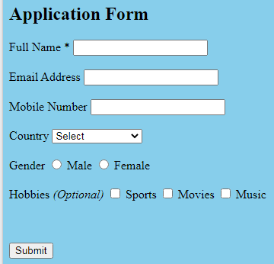

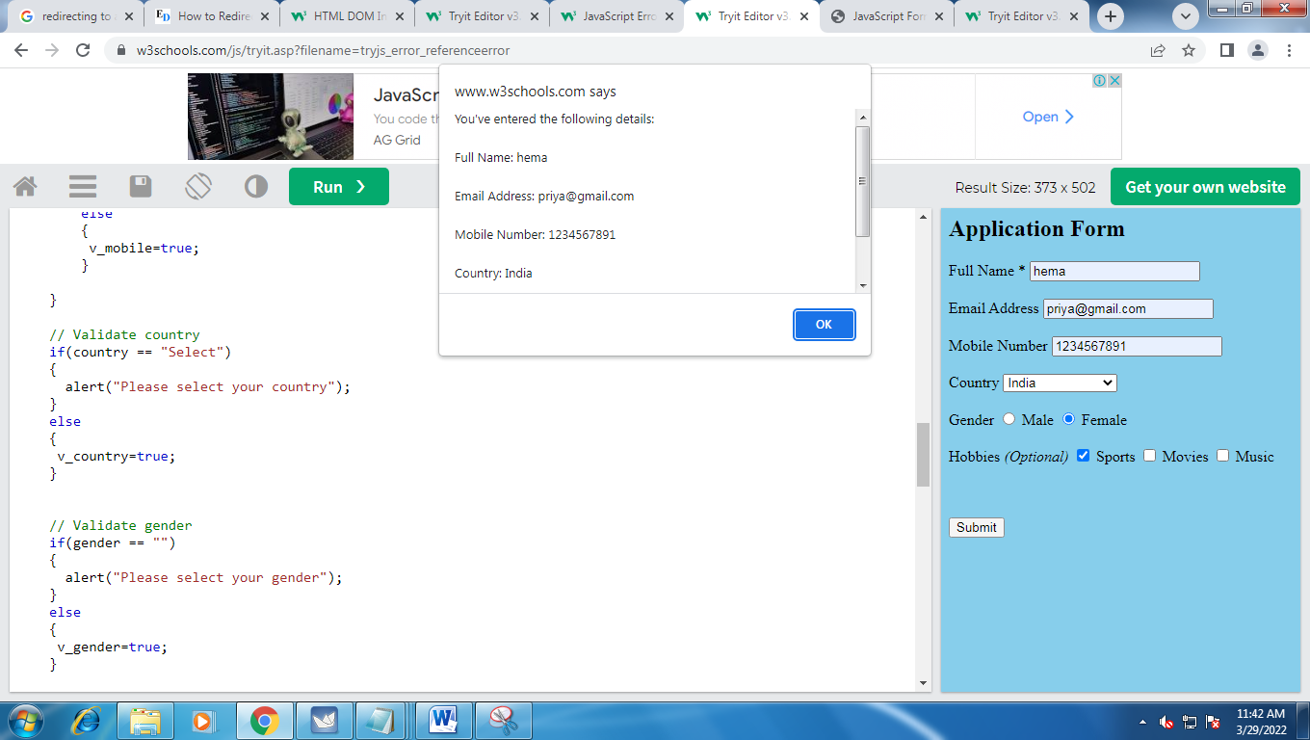

Ex.No: 4.1 INVOKING A SERVLET FROM HTML

MainPage.html
<html>
<body>
<form action="http://localhost:8084/Exp-4a/cal_data" method="POST">
Enter Your Name : <input type="text" name="uname" /> <br>
Enter Mark 1 : <input type="number" name="m1" /> <br>
Enter Mark 2 : <input type="number" name="m2" /> <br>
Enter Mark 3 : <input type="number" name="m3" /> <br>
<input type="submit" value="calculate" />

</form>
</body>
</html>

cal_data.java

import java.io.*;
import javax.servlet.*;
import javax.servlet.annotation.WebServlet;
import javax.servlet.http.*;

@WebServlet(name = "cal_data", urlPatterns = {"/cal_data"})

public class cal_data extends HttpServlet {
public void doPost(HttpServletRequest req, HttpServletResponse res) throws ServletException, IOException
{
res.setContentType("text/html");
PrintWriter out=res.getWriter();

String name=req.getParameter("uname");
int mark1=Integer.parseInt(req.getParameter("m1"));
int mark2=Integer.parseInt(req.getParameter("m2"));
int mark3=Integer.parseInt(req.getParameter("m3"));
int total=mark1+mark2+mark3;
float avg=total/3;

out.println("<html>");
out.println("<table border='1'>");
out.println("<tr><th> User Name: </th><td>"+name+"</td></tr>");
out.println("<tr><th> Mark 1: </th><td>"+mark1+"</td></tr>");
out.println("<tr><th> Mark 2: </th><td>"+mark2+"</td></tr>");
out.println("<tr><th> Mark 3: </th><td>"+mark3+"</td></tr>");
out.println("<tr><th> Total : </th><td>"+total+"</td></tr>");
out.println("<tr><th> Average : </th><td>"+avg+"</td></tr>");
out.println("</table>");
out.println("</html>");
}
}
OUTPUT:

Top of Form
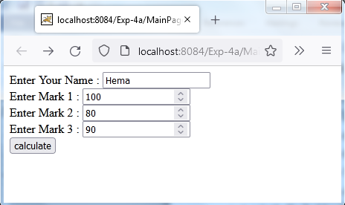

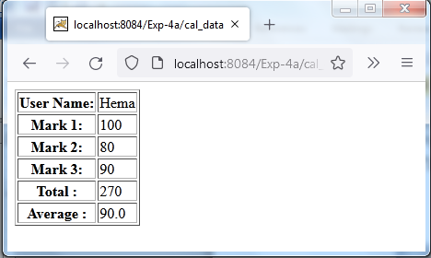

Ex.No: 4.2 SESSION TRACKING FOR A HIT COUNT USING HIDDEN

FORM FIELDS

Home.html
<!DOCTYPE html>
<html>
<head><title>Session Tracking Example</title>
</head>
<body bgcolor="cyan">
<center>
<form action="http://localhost:8084/Exp.4b/FirstServlet" method="get">
Name: <input type="text" name="uname"/><br/>
<input type="hidden" name="id" value="SF1001">
<input type="submit" value="go"/>
</form>
</center>
</body>
</html>

FirstServlet.java
import java.io.*;
import javax.servlet.*;
import javax.servlet.http.*;
import java.util.*;
import javax.servlet.annotation.WebServlet;
@WebServlet(name = "FirstServlet", urlPatterns = {"/FirstServlet"})
public class FirstServlet extends HttpServlet
{
public void service(HttpServletRequest req, HttpServletResponse res) throws ServletException,
IOException
{
res.setContentType("text/html") ;
PrintWriter out = res.getWriter( );
String n=req.getParameter("uname");
String id=req.getParameter("id");
out.print("<center>Hello "+n+"! User ID:"+id+"</center>");
HttpSession session = req.getSession(); // this is how to get a session object
Integer hitNumber = (Integer) session.getAttribute("VisitCount"); // retrieving value from session object
if(hitNumber == null)
{
hitNumber = new Integer(1);
}
else
{
hitNumber = new Integer(hitNumber.intValue()+1) ;
}
session.setAttribute("VisitCount", hitNumber); // storing the value with session object
out.println("Your Session ID: " + session.getId()); // never changes in the whole session
out.println("<br>Session Creation Time: " + new Date(session.getCreationTime()));

// never changes in the whole session
out.println("<br>Time of Last Access: " + new Date(session.getLastAccessedTime()));
// changes for every hit
out.println("<br>Latest Hit Count: " + hitNumber); // increments by 1 for every hit
}
}

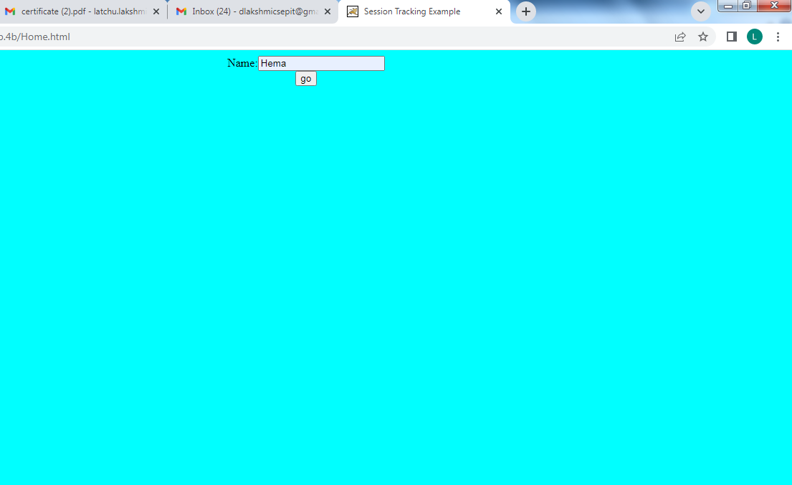

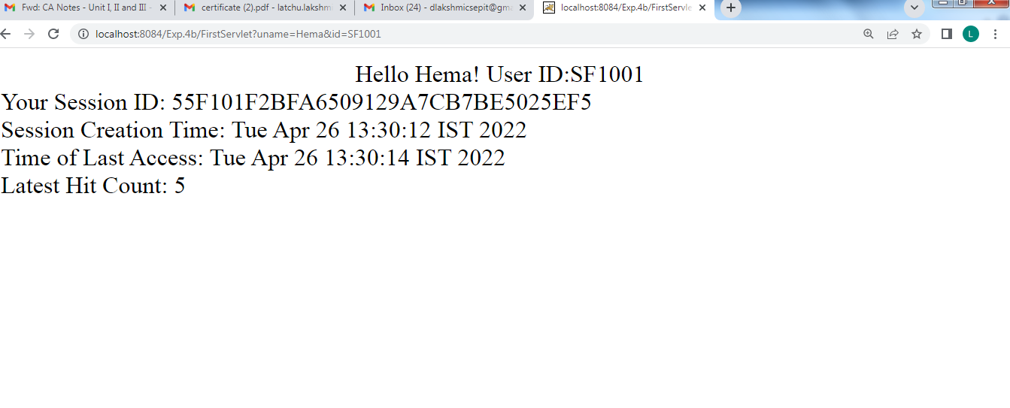

Ex.No: 5 THREE TIER APPLICATION USING SERVLETS AND

DATABASES

<!DOCTYPE html>
<html>
<body>
<form action="http://localhost:8084/Exp.5/MarkServlet" method="GET">
Seat Number:
<input type="text" name="Seat_no">
Name:
<input type="text" name="Name" size="50">
<hr/>

<hr/>
<b>1. Apache is an open source web server</b><br/>
<input type="radio" name="group1" value="True">True
<input type="radio" name="group1" value="False">False<br>
<br/>

<b>2. Keywords can be used as variable names.</b><br/>
<input type="radio" name="group2" value="True">True
<input type="radio" name="group2" value="False">False<br>
<br/>

<b>3. Tim-Berners Lee is the originator of Java.</b><br/>
<input type="radio" name="group3" value="True">True
<input type="radio" name="group3" value="False">False<br>
<br/>

<b>4.JPG is not a video file extension.</b><br/>
<input type="radio" name="group4" value="True">True
<input type="radio" name="group4" value="False">False<br>
<br/>

<b>5. HTTP is a statefull protocol</b><br/>
<input type="radio" name="group5" value="True">True
<input type="radio" name="group5" value="False">False<br>
<hr/>
<center>
<input type = "submit" value="Submit">
<input type = "reset" value="Clear"><br><br>
</center>
</form>

</body>
</html>

MarkServlet.java
import java.io.*;
import java.util.logging.Level;
import java.util.logging.Logger;
import javax.servlet.*;
import javax.servlet.http.*;
import java.sql.*;
public class MarkServlet extends HttpServlet
{
public void doGet(HttpServletRequest request,HttpServletResponse response) throws ServletException, IOException
{
String SeatNum,Name;
String ans1,ans2,ans3,ans4,ans5;
int a1,a2,a3,a4,a5;
a1=a2=a3=a4=a5=0;
PrintWriter out=response.getWriter();

SeatNum = request.getParameter("Seat_no");
Name = request.getParameter("Name");
ans1 =request.getParameter("group1");
if(ans1.equals("True"))
a1=2;
else
a1=0;
ans2 = request.getParameter("group2");
if(ans2.equals("False"))
a2=2;
else
a2=0;
ans3 = request.getParameter("group3");
if(ans3.equals("False"))
a3=2;
else
a3=0;
ans4 = request.getParameter("group4");
if(ans4.equals("True"))
a4=2;
else
a4=0;
ans5 = request.getParameter("group5");
if(ans5.equals("False"))
a5=2;
else
a5=0;

int Total=a1+a2+a3+a4+a5;

Connection connect=null;
Statement stmt=null;
ResultSet rs=null;
try {
try {
Class.forName("sun.jdbc.odbc.JdbcOdbcDriver");
} catch (ClassNotFoundException ex) {

}
connect = DriverManager.getConnection("jdbc:odbc:EQuiz","2cs244","2cs244");

stmt = connect.createStatement();
String query = "INSERT INTO student_entry VALUES (" +SeatNum + ", '" + Name + "', "+Total+ ")";
int result = stmt.executeUpdate(query);

query = "SELECT * FROM student_entry";
rs = stmt.executeQuery(query);

out.println("<html><head><title>Student Mark List</title></head>");
out.println("<body bgcolor=khaki>");
out.println("<center>");
out.println("<h2>Students Marksheet</h2>");
out.println("<h3>Name of the College:PANIMALAR INSTITUTE OF TECHNOLOGY</h3>");
out.println("<table border='1' cellspacing='0' cellpadding='0'>");
out.println("<tr>");
out.println("<td><b>Seat_No</b></td>");
out.println("<td><b>Name</b></td>");
out.println("<td><b>Marks</b></td>");
out.println("</tr>");
while(rs.next())
{
out.println("<tr>");
out.println("<td>"+rs.getInt(1)+"</td>");
out.println("<td>"+rs.getString(2)+"</td>");
out.println("<td>"+rs.getInt(3)+"</td>");
out.println("</tr>");
}
out.println("</table></center>");
out.println("</body></html>");
rs.close();
stmt.close();
connect.close();
}

catch(SQLException e)
{
System.out.println(e);
}
}
}

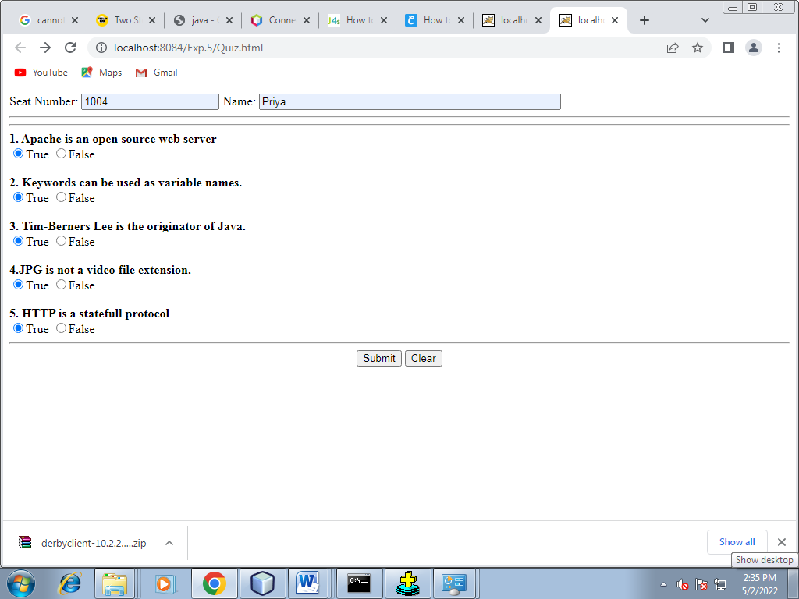

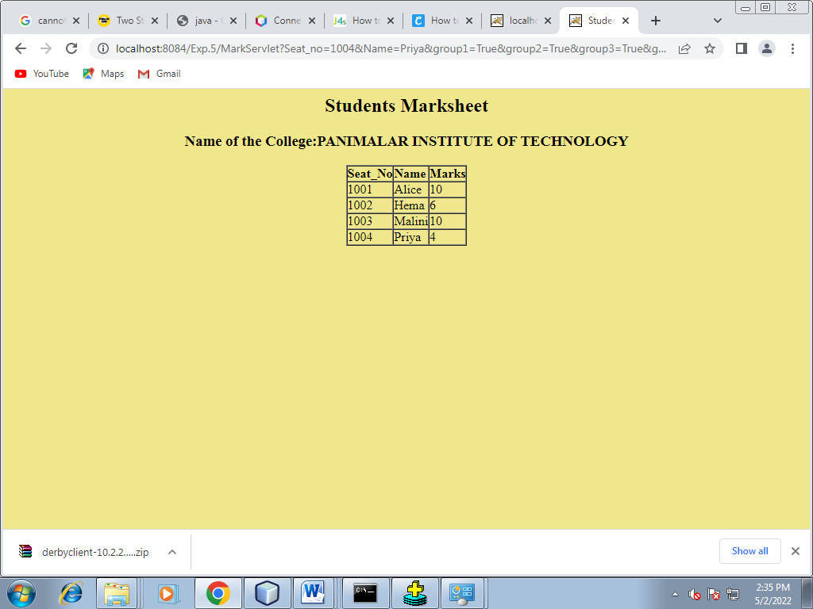

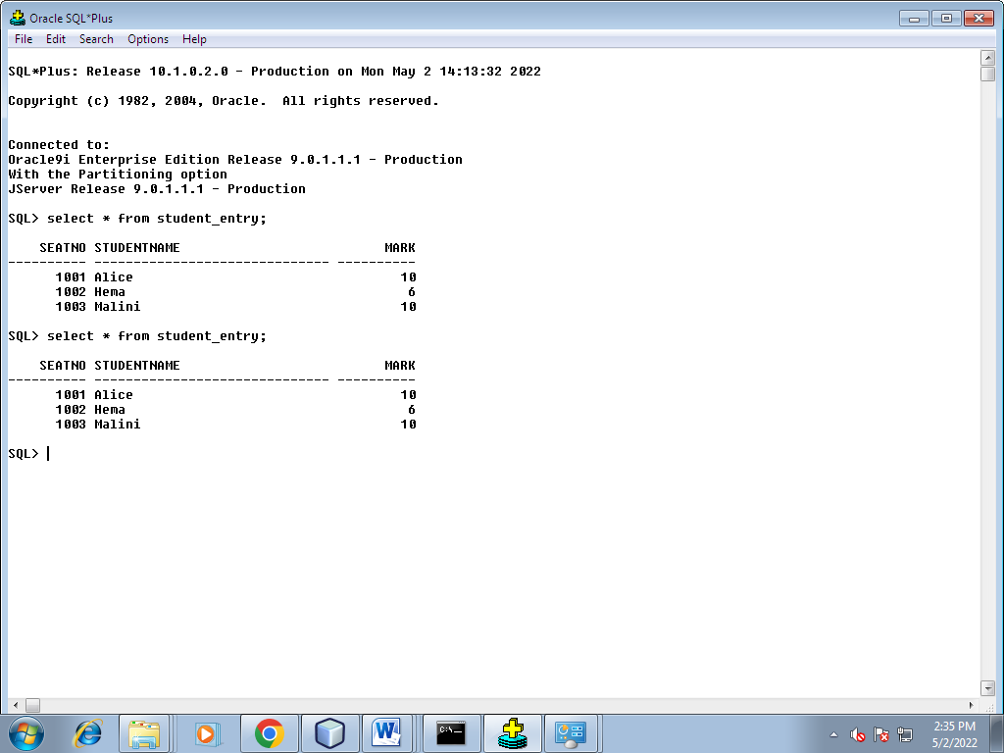

Ex.No: 6 CONVERTING A STATIC WEB PAGES TO DYNAMIC WEB PAGES USING JSP AND COOKIES
Form.html
<html>
<head>
<title>Cookie Input Form</title>
</head>
<body>
<form method="post" action="setCookies.jsp">

<p><b>Enter Your User Id: </b><input type="text" name="userid"><br>

<input type="submit" value="Submit">
</form>
</body>
</html>
setCookies.jsp
<%@ page language="java" import="java.util.*"%>
<%
String userid=request.getParameter("userid");
if(userid==null) userid="";
Date now = new Date();
String timestamp = now.toString();
Cookie cookie=new Cookie ("userid",userid);
Cookie cookie1=new Cookie ("username","Tim");
Cookie cookie2=new Cookie ("credit_card_no","123456789");

response.addCookie(cookie);
response.addCookie(cookie1);
response.addCookie(cookie2);

%>

<html>
<head>
<title>Cookie Saved</title>
</head>
<body>
<center> <h2>View Cookie Information of your web page</h2></center>
<hr size="5 color="magenta">
<p><a href="showCookie.jsp">Next Page to view the cookie value</a><p>

</body>
</html>
showCookie.jsp
<%@ page language="java" %>
<%
String cookieName = "userid";
Cookie cookies [] = request.getCookies ();
Cookie myCookie = null;
if (cookies != null)
{
for (int i = 0; i < cookies.length; i++)
{
myCookie = cookies[i];
%>
<p> <h2><%=myCookie.getName()%>:<%=myCookie.getValue() %></h2></p>
<%

}
}
else
%>
No Cookie found with the name
<html>
<head>
<title>Show Saved Cookie</title>
</head>
<body bgcolor="pink">

</body>
</html>

OUTPUT:
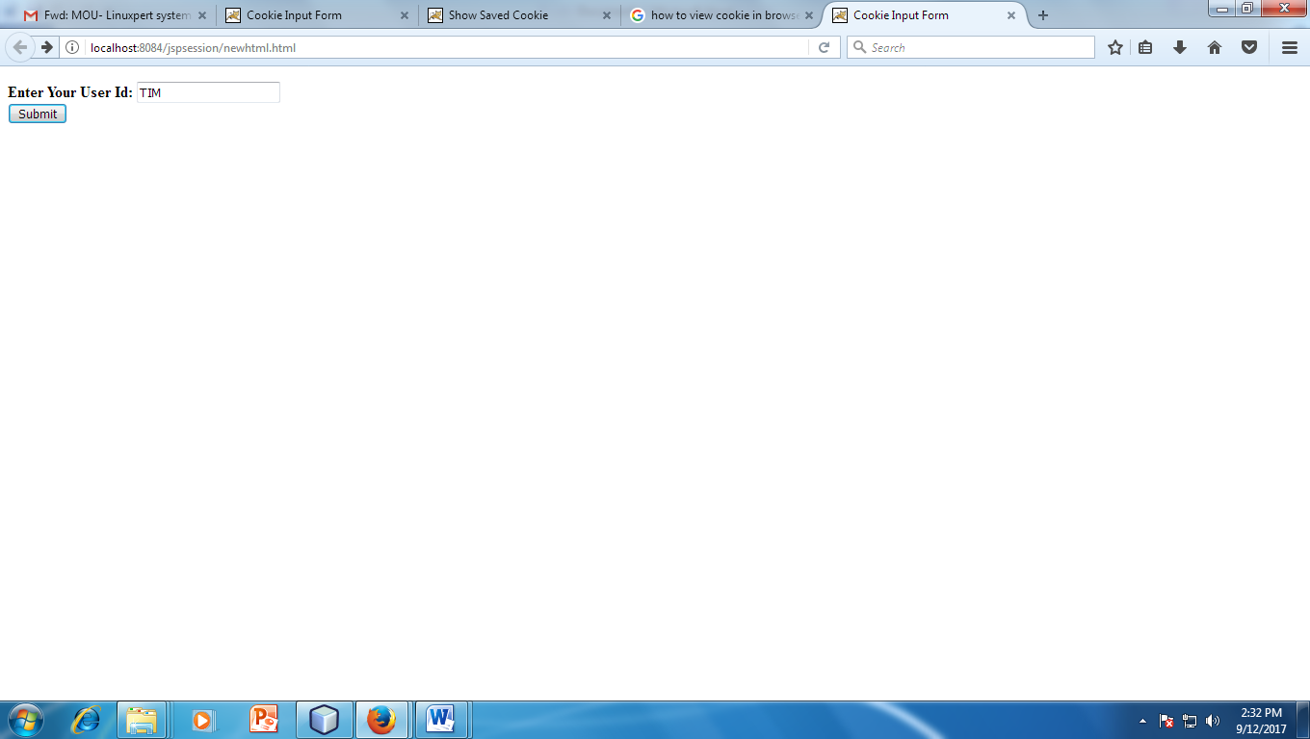
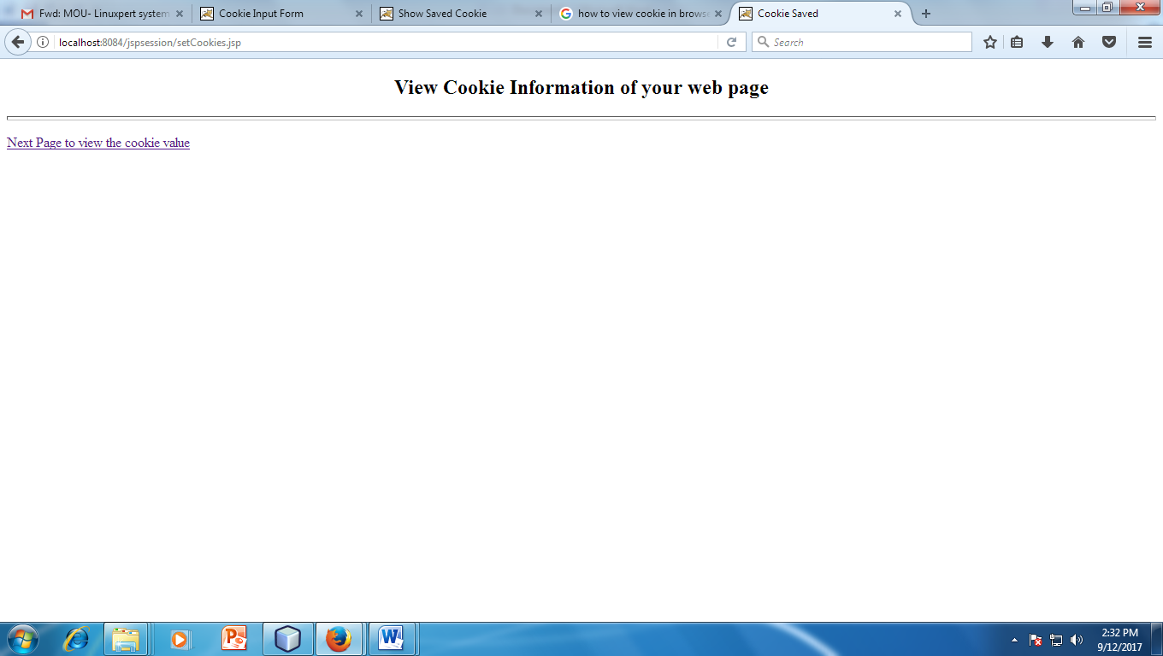
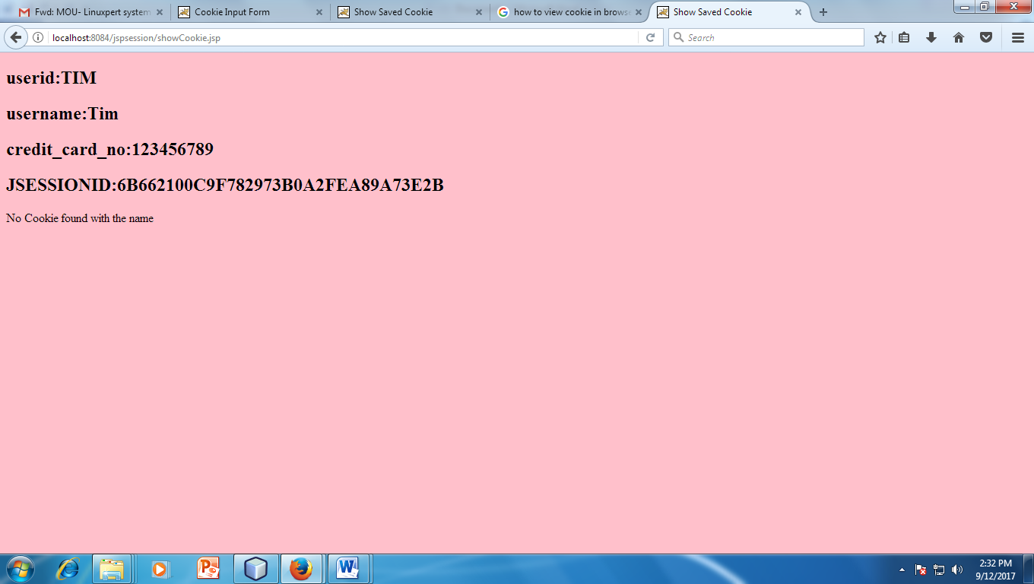

Ex.No: 7 CONVERTING A STATIC WEB PAGES TO DYNAMIC WEB

PAGES USING JSP WITH DATABASE CONNECTION

Form.html:
<%@page contentType="text/html" pageEncoding="UTF-8"%>
<!DOCTYPE html>
<html>
<head>
<meta http-equiv="Content-Type" content="text/html; charset=UTF-8">
<title>JSP Page</title>
</head>
<body bgcolor="#BFC9CA " >

<center><h1>BOOK CATALOGUE</h1>

<table align="center" border ="0">
<tr cellspacing="15" cellpadding="10"><td>
<a href="booklist.jsp"> <button type="reset">view Book List</button> </a><br>
<br></td></tr>
<tr cellspacing="15"><td>
<a href="viewbook.html">
<button type="reset">User Registration</button></a>
<br> </td></tr>
<tr cellspacing="15"><td><br><a href="bookcount.jsp">
<button type="reset">Book Available</button>
</a><br></td></tr>
</table>
</center>

</body>
</html>
Registration :
<!DOCTYPE html>
<html>
<head>
<title></title>
<meta http-equiv="Content-Type" content="text/html; charset=UTF-8">
</head>
<body bgcolor="#BFC9CA " >
<center><h1>ENTER USER DETAILS</h1>
<form action="newjsp.jsp" method="get">
Name:<input type="text" name="name"><br><br>
Mobile:<input type="text" name="mobile"><br><br>
DOB:<input type="text" name="dob"><br><br>
<input type="submit" value="submit">
</form>
</center>
</body>
</html>

NEWJSP:
<!DOCTYPE html>
<html>
<head>
<meta http-equiv="Content-Type" content="text/html; charset=UTF-8">
<title>JSP Page</title>
</head>
<body>
<%@page import=" java.sql.*;" %>
<% String p= request.getParameter("name");
String r=request.getParameter("mobile");
String t=request.getParameter("dob");
out.println(p);
Connection con=null;
Statement stmt=null;
ResultSet rs=null;
try {
Class.forName("org.apache.derby.jdbc.ClientDriver");
con =DriverManager.getConnection("jdbc:derby://localhost:1527/sample;create=true;user=app;password=app");
stmt=con.createStatement();
stmt.executeUpdate("INSERT into APP.EVENT(name,mobile,dob) values(\'"+p+"\',\'"+r+"\',\'"+t+"\')");
}
catch(Exception e){
out.println(e);

}
%>
</body>
</html>
BOOKLIST.JSP
<%@page contentType="text/html" pageEncoding="UTF-8"%>
<!DOCTYPE html>
<html>
<head>
<meta http-equiv="Content-Type" content="text/html; charset=UTF-8">
<title>JSP Page</title>
</head>
<body >
<h2>BOOK DETAILS ...</h2>
<%@page import=" java.sql.*;" %>
<%
Connection con=null;
Statement stmt=null;
ResultSet rs=null;
try {
Class.forName("org.apache.derby.jdbc.ClientDriver");
con =DriverManager.getConnection("jdbc:derby://localhost:1527/sample;create=true;user=app;password=app");
stmt=con.createStatement();
String sql = "SELECT * FROM APP.BOOK";
rs = stmt.executeQuery(sql);
while (rs.next()) {
%>
<table border="1" >
<tr bgcolor="#F6DDCC">
<td><%=rs.getString("CODE")%></td>
<td><%=rs.getString("name")%></td>
</tr>
</table>
<%
}

}
catch(Exception e){
out.println(e);

}
%>
</body>
</html>

OUTPUT:
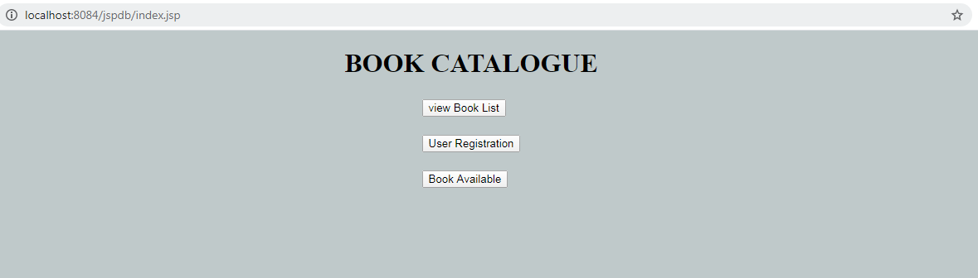
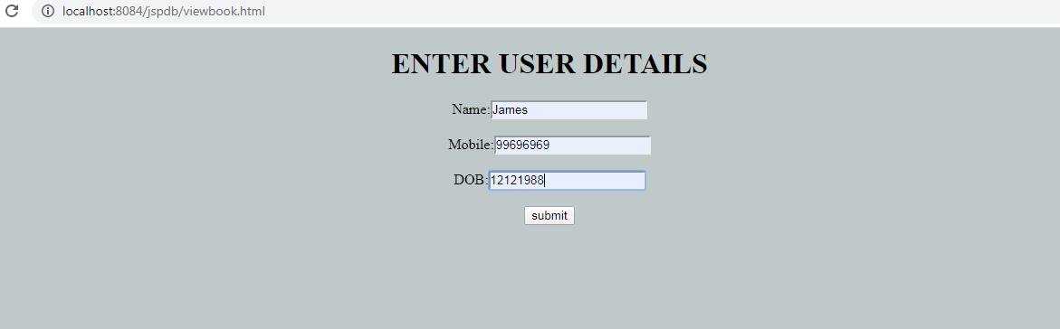
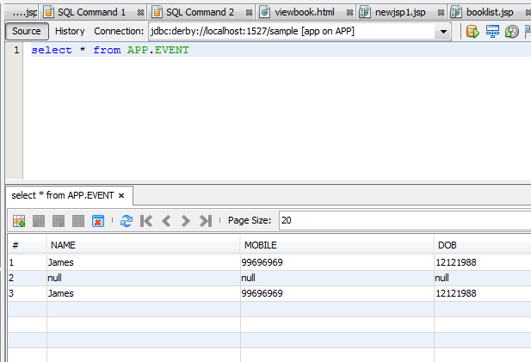
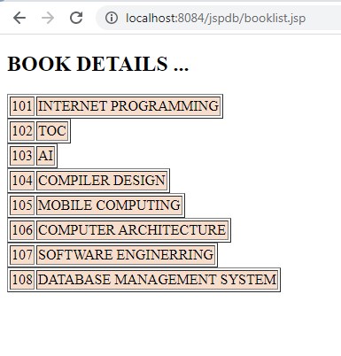
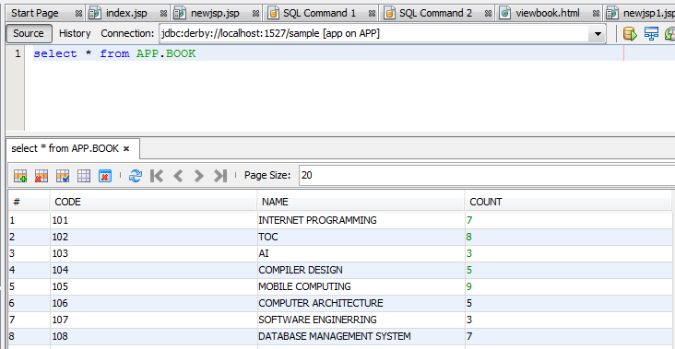

Ex.No: 8 EXTRACTING INFORMATION FROM XML DOCUMENT

Index.html
<html>
<!--DOM with javascript>
<head>
<title>user profile example</title>
</head>
<body>
<script type="text/JavaScript">
var xmldoc=new ActiveXObject("Microsoft.XMLDOM");
xmldoc.load("Data.xml");
var ele=xmldoc.documentElement;
var y=window.prompt("enter user num",1);
var node=ele.childNodes.item(y-1);
for(var i=0;i<node.childNodes.length;i++)
{
var child=node.childNodes.item(i);
var val=child.firstChild;
document.write("<h2>"+child.nodeName+":"+val.nodeValue);
}
</script>
</body>
</html>

Data.xml
<?xml version="1.0"?>
<userdata>
<user1>
<regno>561</regno>
<name> chandu</name>
<phno>9989891510</phno>
<address>chennai</address>
</user1>
<user2>
<regno>540</regno>
<name> karteek</name>
<phno>9701443556</phno>
<address>salem</address>
</user2>
<user3>
<regno>525</regno>
<name> giri</name>
<phno>9897895301</phno>
<address>hyderabad</address>
</user3>
<user4>
<regno>526</regno>
<name>gopi</name>
<phno>9999789540</phno>
<address>cochin</address>
</user4>
<user5>
<regno>513</regno>
<name> manoj</name>
<phno>9989233331</phno>
<address>hyderabad</address>
</user5>
<user6>
<regno>514</regno>
<name> balaji</name>
<phno>9999789560</phno>
<address>vizag</address>
</user6>
<user7>
<regno>567</regno>
<name>kiran </name>
<phno>9999178957</phno>
<address>vijayanagar</address>
</user7>
<user8>
<regno>518</regno>
<name> sekhar</name>
<phno>789580</phno>
<address>bombay</address>
</user8>
<user9>
<regno>517</regno>
<name>chaitu</name>
<phno>789590</phno>
<address>salem</address>
</user9>
<user10>
<regno>595</regno>
<name> sravan</name>
<phno>9000789500</phno>
<address>kovai</address>
</user10>
</userdata>

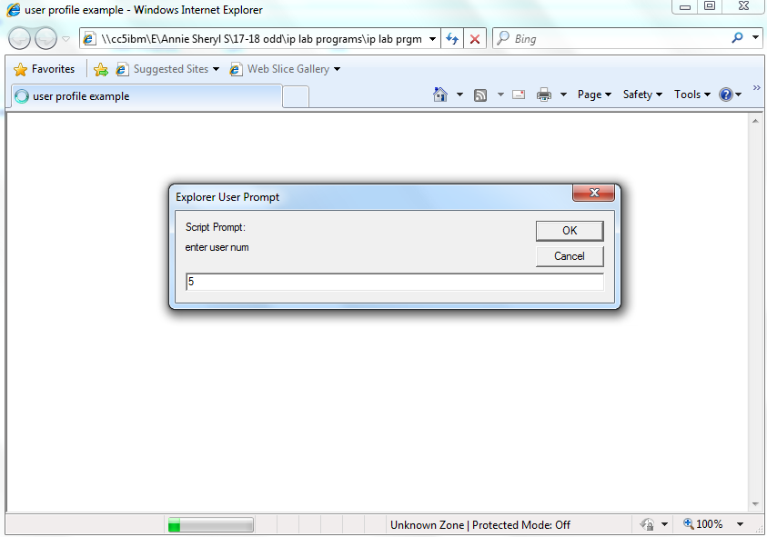

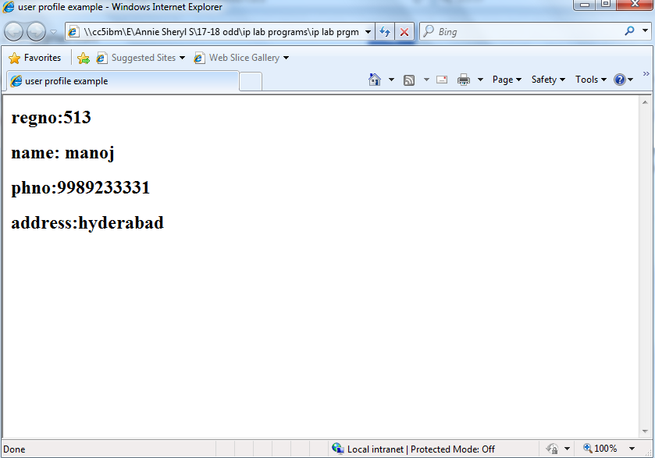

Ex.No: 9.1 FORM VALIDATION USING PHP REGULAR EXPRESSION

Index.html
<!DOCTYPE HTML>
<html>
<head>
<style>
.center {
margin: auto;
width: 50%;
border: 3px solid green;
padding: 10px;
}
.error {color: #FF0000;}
</style>
</head>
<body align="center" bgcolor="cyan">

<?php
// define variables and set to empty values
$nameErr = $emailErr = $genderErr = $websiteErr = "";
$name = $email = $gender = $comment = $website = "";

if ($_SERVER["REQUEST_METHOD"] == "POST") {
if (empty($_POST["name"])) {
$nameErr = "Name is required";
} else {
$name = test_input($_POST["name"]);
// check if name only contains letters and whitespace
if (!preg_match("/^[a-zA-Z ]*$/",$name)) {
$nameErr = "Only letters and white space allowed";
}
}

if (empty($_POST["email"])) {
$emailErr = "Email is required";
} else {
$email = test_input($_POST["email"]);
// check if e-mail address is well-formed
$pattern="'^[a-zA-Z0-9._-]+@[a-zA-Z0-9-] +.[a-zA-Z.]{2,5}$'";
if(!preg_match($pattern,$email))
{
$emailErr = "INVALID EMAIL";
}

}
}

if (empty($_POST["website"])) {
$website = "";
} else {
$website = test_input($_POST["website"]);
// check if URL address syntax is valid
if (!preg_match("/\b(?:(?:https?|ftp):\/\/|www\.)[-a-z0-9+&@#\/%?=~_|!:,.;]*[-a-z0-9+&@#\/%=~_|]/i",$website)) {
$websiteErr = "Invalid URL";
}
}

if (empty($_POST["comment"])) {
$comment = "";
} else {
$comment = test_input($_POST["comment"]);
}

if (empty($_POST["gender"])) {
$genderErr = "Gender is required";
} else {
$gender = test_input($_POST["gender"]);

}

function test_input($data) {
$data = trim($data);
$data = stripslashes($data);
$data = htmlspecialchars($data);
return $data;
}
?>

<h2>PHP Form Validation</h2>
<p><span class="error">* required field</span></p>
<form method="post" action="<?php echo htmlspecialchars($_SERVER["PHP_SELF"]);?>">
Name: <input type="text" name="name">
<span class="error">* <?php echo $nameErr;?></span>
<br><br>
E-mail: <input type="text" name="email">
<span class="error">* <?php echo $emailErr;?></span>
<br><br>
Website: <input type="text" name="website">
<span class="error"><?php echo $websiteErr;?></span>
<br><br>
Comment: <textarea name="comment" rows="5" cols="40"></textarea>
<br><br>
Gender:
<input type="radio" name="gender" value="female">Female
<input type="radio" name="gender" value="male">Male
<input type="radio" name="gender" value="other">Other
<span class="error">* <?php echo $genderErr;?></span>
<br><br>
<input type="submit" name="submit" value="Submit">
</form>

<?php
echo "<h2>Your Input:</h2>";
echo $name;
echo "<br>";
echo $email;
echo "<br>";
echo $website;
echo "<br>";
echo $comment;
echo "<br>";
echo $gender;
?>

</body>
</html>

OUTPUT:
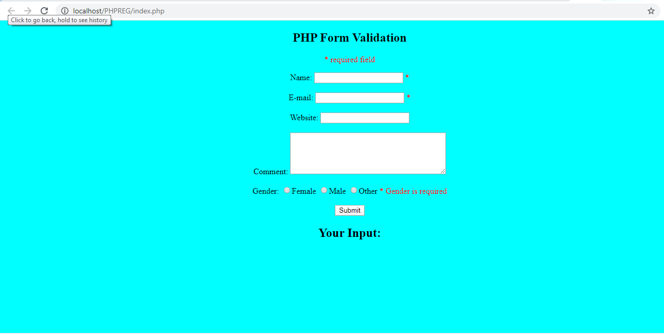

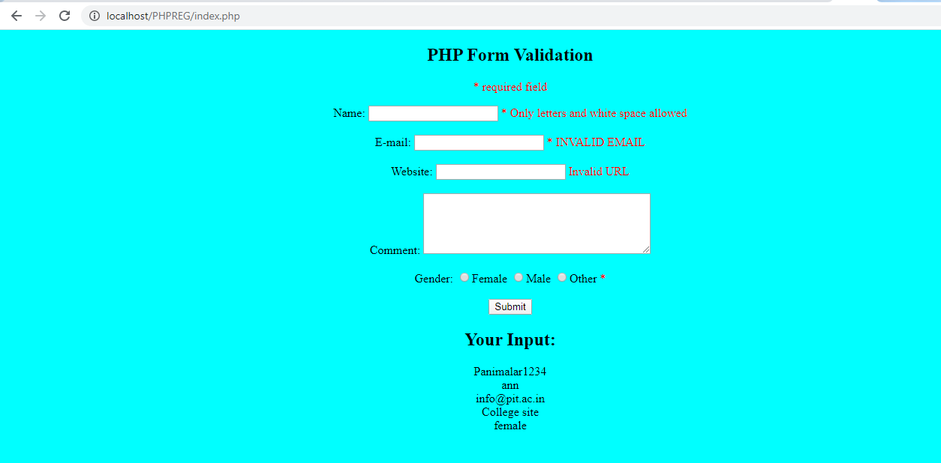

Ex.No: 9.2 STORING FORM DATA INTO DATABASE USING PHP

Index.html
<!DOCTYPE html>
<html>
<head>
<meta http-equiv="Content-Type" content="text/html; charset=UTF-8">
<title></title>
</head>
<body bgcolor="Cyan" align ="center">
<?php

$con = mysql_connect('localhost','root','');
if($con)
echo "Connected Successfully";
echo "<br>";

if(mysql_query("CREATE DATABASE dbnew",$con))
{
echo "Database Connected";
}
else
{
echo "Error in creating Database";
}
mysql_select_db("dbnew",$con);
$query="CREATE TABLE student(name VARCHAR(20),rno VARCHAR(20),mark VARCHAR(20))";
mysql_query($query,$con);
echo "Table created";

$query1="INSERT INTO student(name,rno,mark) VALUES('James','101','76')";
mysql_query($query1,$con);
$query2="INSERT INTO student(name,rno,mark) VALUES('Gosling','102','80')";
mysql_query($query2,$con);
echo "Data inserted successfully";
$result=mysql_query("SELECT * FROM student");

echo "<center>";
echo "<table border=3>";
echo "<th>Name</th>";
echo "<th>Rollno</th>";
echo "<th>Mark</th>";
while($row=mysql_fetch_array($result))
{
echo "<tr><td>";
echo $row['name'];
echo "</td><td>";
echo $row['rno'];
echo "</td><td>";
echo $row['mark'];
echo "</td></tr>";
}
echo "</table></center>";
$query3="DELETE FROM student WHERE name='Gosling'";
mysql_query($query3,$con);
echo "Data Deleted successfully";
$result1=mysql_query("SELECT * FROM student");
echo "<center>";
echo "<table border=3>";
echo "<th>Name</th>";
echo "<th>Rollno</th>";
echo "<th>Mark</th>";
while($row=mysql_fetch_array($result1))
{

echo "<tr><td>";
echo $row['name'];
echo "</td><td>";
echo $row['rno'];
echo "</td><td>";
echo $row['mark'];
echo "</td></tr>";

}

mysql_close($con);

?>
</body>
</html>

OUTPUT :
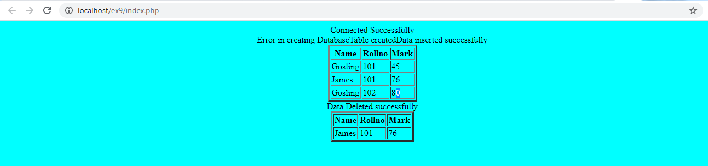

Ex.No: 10
CREATING A SIMPLE WEB SERVICE TO ACCESS A PRODUCT
PRODUCT

sale.html

<!DOCTYPE HTML PUBLIC "-//W3C//DTD HTML 4.01 Transitional//EN">
<html>
<head>
<title></title>
<meta http-equiv="Content-Type" content="text/html; charset=UTF-8">
</head>
<body>
<center><h1>PREDICT THE SALE OF THE PRODUCT </h1></center>
<hr size="10" color="Green">
<form action="http://localhost:8080/WebClient/predict.jsp" method="post">
<table><tr>

<td>Select the product</td>
<td><select name="product">
<option value="iPhone">iPhone</option>
<option value="Tablet">Tablet</option>
<option value="Laptop">Laptop</option>
</select>
</td></tr>
<tr>
<td>Current Year:</td>
<td><input type="number" name="c_year" value="2016" readonly/></td>
</tr>
<tr>
<td>Enter the Quantity Sold:</td>
<td><input type="number" name="quant"/></td>
</tr>
</table>
<input type="submit" value="Get Report"/>
</form><hr/>
</body></html>

Predict.jsp (WeService Client)

<%@page contentType="text/html" pageEncoding="UTF-8"%>
<!DOCTYPE HTML PUBLIC "-//W3C//DTD HTML 4.01 Transitional//EN"
"http://www.w3.org/TR/html4/loose.dtd">

<html>
<head>
<meta http-equiv="Content-Type" content="text/html; charset=UTF-8">
<title>JSP Page</title>
</head>
<body>
<%-- start web service invocation --%><hr/>
<%
try {
com.me.converter.ProductSaleService service = new com.me.converter.ProductSaleService();
com.me.converter.ProductSale port = service.getProductSalePort();
// TODO initialize WS operation arguments here
java.lang.String pName = request.getParameter("product");
int quantity = Integer.parseInt(request.getParameter("quant"));
// TODO process result here
java.lang.String result = port.predict(pName, quantity);
out.println("<center><h1>Result</h1></center><hr>"+result);
} catch (Exception ex) {
// TODO handle custom exceptions here
}
%>
<%-- end web service invocation --%><hr/>

</body>
</html>

Productsale.java (Web Service)

package com.me.converter;
import java.sql.*;
import javax.jws.WebMethod;
import javax.jws.WebParam;
import javax.jws.WebService;
@WebService()
public class ProductSale {
/**
* Web service operation
*/
@WebMethod(operationName = "predict")
public String predict(@WebParam(name = "p_name")
String p_name, @WebParam(name = "quantity")
int quantity) {
Connection con=null;
Statement stmt=null;
ResultSet rs=null;
String dbURL="jdbc:derby://localhost:1527/product";
int qty = 0;
int diff;
String res=null;
try {
Class.forName("org.apache.derby.jdbc.ClientDriver").newInstance();
//Get a connection
con = DriverManager.getConnection(dbURL);
if(con!=null)
{
System.out.println("Connected to database");
}
stmt=con.createStatement();
rs=stmt.executeQuery("select * from product_details ");
while(rs.next())
{
if(rs.getString(1).equals(p_name))
{
qty=rs.getInt(4);
System.out.println(qty);
}
}
diff=quantity-qty;
res="Quantity sold in 2015: "+qty+"<br> Quantity sold in 2016: "+quantity;
if(diff > 0 )
res+="<br>Sales of this product in 2017 can be"+diff+"%";
else
res+="<br>Sales of this product in 2017 cannot be increased";
}
catch (Exception except)
{
except.printStackTrace();
}
return res;
}
}

Database Schema:

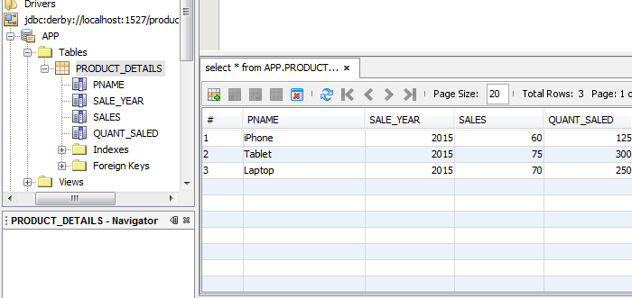

OUTPUT:

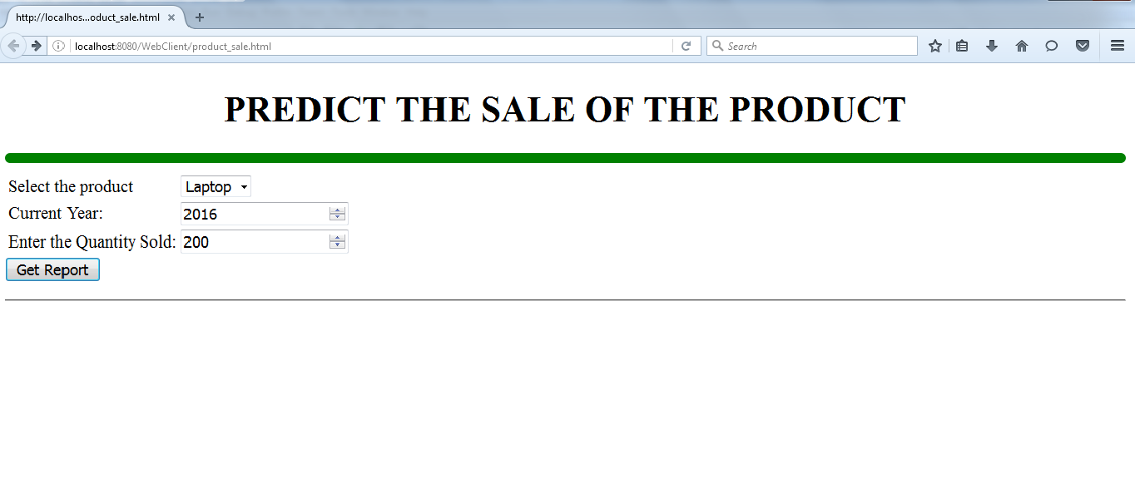

ADDITIONAL EXPERIMENTS

Ex.No: 11 DESIGN A BUTTON TO SCROLL TOP OF THE PAGE USING CSS AND HTML
Index.html
<!DOCTYPE html>
<html>
<head>
<meta name="viewport" content="width=device-width, initial-scale=1">
<style>
body {
font-family: Arial, Helvetica, sans-serif;
font-size: 20px;
}

#myBtn {
display: none;
position: fixed;
bottom: 20px;
right: 30px;
z-index: 99;
font-size: 18px;
border: none;
outline: none;
background-color: red;
color: white;
cursor: pointer;
padding: 15px;
border-radius: 4px;
}

#myBtn:hover {
background-color: #555;
}
</style>
</head>
<body>

<button onclick="topFunction()" id="myBtn" title="Go to top">Top</button>

<div style="background-color:black;color:white;padding:30px">Scroll Down</div>
<div style="background-color:lightgrey;padding:30px 30px 2500px">This example demonstrates how to create a "scroll to top" button that becomes visible
<strong>when the user starts to scroll the page</strong>.</div>

<script>
//Get the button
var mybutton = document.getElementById("myBtn");

// When the user scrolls down 20px from the top of the document, show the button
window.onscroll = function() {scrollFunction()};

function scrollFunction() {
if (document.body.scrollTop > 20 || document.documentElement.scrollTop > 20) {
mybutton.style.display = "block";
} else {
mybutton.style.display = "none";
}
}

// When the user clicks on the button, scroll to the top of the document
function topFunction() {
document.body.scrollTop = 0;
document.documentElement.scrollTop = 0;
}
</script>
</body>
</html>

Output:
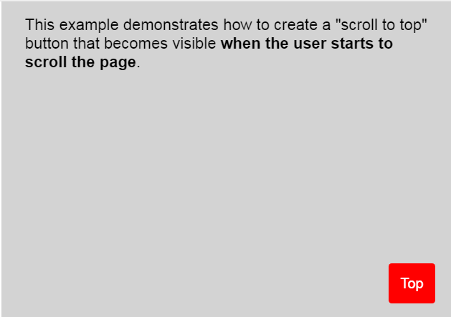
Ex.No: 12 DEMONSTRATE FADE FROM ONE COLOR TO ANOTHER ON LOAD USING JAVASCRIPT.
FRAMES.HTML
<frameset rows="25%,75%">
<frame src="node.html">
<frame src="node1.html">
</frameset>
NODE.HTML
<!DOCTYPE html>
<html>
<body alig="center">
<h1><align="center">Changing colour Palette </align></h1>
</body>
</html>
NODE1.HTML
<!DOCTYPE html>
<html>
<body>
<script>
var colors = ["red", "orange", "yellow", "green", "blue", "purple"];
var currentIndex = 0;

setInterval(function() {
document.body.style.cssText = "background-color: " + colors[currentIndex];
currentIndex++;
if (currentIndex == undefined || currentIndex >= colors.length) {
currentIndex = 0;
}
}, 1000);
</script>
</body>
</html>

OUTPUT:
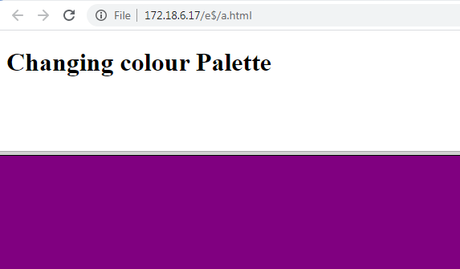
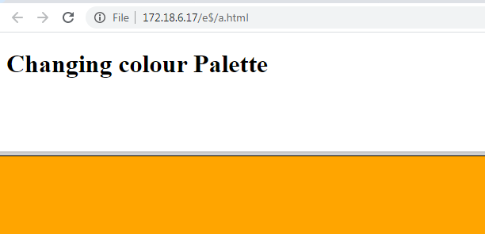

Ex.No: 13 CREATE POPUP BOXES IN JAVASCRIPT
<!doctype html>
<html>
<head>
<meta charset="utf-8">
<title>Untitled Document</title>
</head>
<body>
<script type="text/javascript">
var input = prompt("Enter the number to get factorial of: ");
var result = input;
for(var i=1;i < input;i++){
result = i * result;
}
document.write(result);
</script>
</body>
</html>
OUTPUT:
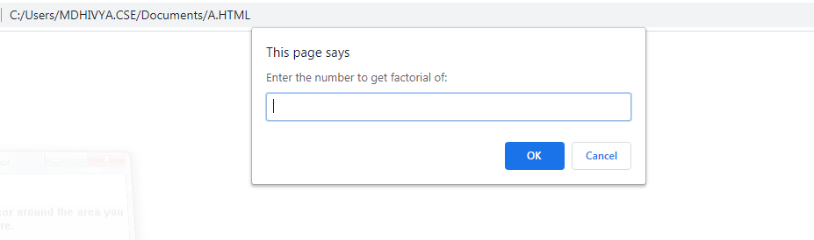
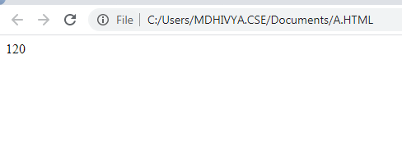

Ex.No: 14 SIMPLE PROGRAM USING STRUTS FRAMEWORK.
AIM:
Implement the “Hello World!” program using JSP Struts Framework.

PROCEDURE
Step 1:
In tomcat install directory
Open tomcat/webapps
Create a subdirectory (ts)
Copy the struts-blank.war file
At that directory path in cmd give the command as
Jar xvf struts-blank.war
Step 2:
create a directory (work in e:\) and copy struts.jar,servlet-api.jar into work d directory. Then set the classpath as
set classpath=struts.jar;servlet-api.jar;
then copy the ActionOne.class file to webapps/ts/WEB-INF/classes
ActionOne.java:
import java.io.*;
import javax.servlet.*;
import javax.servlet.http.*;
import org.apache.struts.action.*;
public class ActionOne extends Action
{
public ActionForward execute(ActionMapping mapping,ActionForm form,HttpServletRequest request,HttpServletResponse response)throws Exception
{
System.out.println("----Action executed------");
PrintWriter pw=response.getWriter();
pw.println("HELLO WORLD");
return null;
}
}

step 3:
struts-config.xml
<?xml version="1.0" encoding="UTF-8"?>
<struts-config>
<action-mappings>
<action path="/xxx" type="ActionOne"/>
</action-mappings>
</struts-config>

Step 4:
web.xml
<?xml version="1.0" encoding="ISO-8859-1"?>
<web-app>
<servlet>
<servlet-name>action</servlet-name>
<servlet-class>org.apache.struts.action.ActionServlet</servlet-class>
<init-param>
<param-name>config</param-name>
<param-value>/WEB-INF/struts-config.xml</param-value>
</init-param>
<init-param>
<param-name>debug</param-name>
<param-value>2</param-value>
</init-param>
<init-param>
<param-name>detail</param-name>
<param-value>2</param-value>
</init-param>
<load-on-startup>2</load-on-startup>
</servlet>
<!-- Standard Action Servlet Mapping -->
<servlet-mapping>
<servlet-name>action</servlet-name>
<url-pattern>*.do</url-pattern>
</servlet-mapping>
<!-- The Usual Welcome File List -->
<welcome-file-list>
<welcome-file>index.jsp</welcome-file>
</welcome-file-list>
<!-- Struts Tag Library Descriptors -->
<taglib>
<taglib-uri>/tags/struts-bean</taglib-uri>
<taglib-location>/WEB-INF/struts-bean.tld</taglib-location>
</taglib>
<taglib>
<taglib-uri>/tags/struts-html</taglib-uri>
<taglib-location>/WEB-INF/struts-html.tld</taglib-location>
</taglib>
<taglib>
<taglib-uri>/tags/struts-logic</taglib-uri>
<taglib-location>/WEB-INF/struts-logic.tld</taglib-location>
</taglib>
<taglib>
<taglib-uri>/tags/struts-nested</taglib-uri>
<taglib-location>/WEB-INF/struts-nested.tld</taglib-location>
</taglib>
<taglib>
<taglib-uri>/tags/struts-tiles</taglib-uri>
<taglib-location>/WEB-INF/struts-tiles.tld</taglib-location>
</taglib>
</web-app>
step 5:
then in I.E give the url as
http://localhost:8080/ts/xxx.do

OUTPUT:
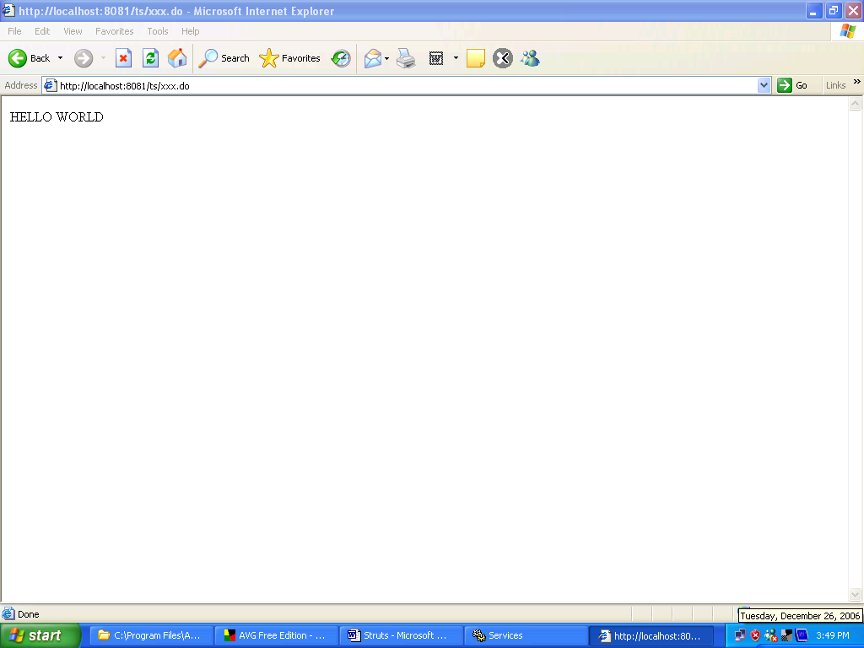

RESULT
Thus the “Hello World!” program using JSP Struts Framework was done successfully.
Ex.No: 15 DYNAMIC WEB PAGE CREATION USING AJAX
Coding:
<?php
// Array with names
$a[] = "Anna";
$a[] = "Brittany";
$a[] = "Cinderella";
$a[] = "Diana";
$a[] = "Eva";
$a[] = "Fiona";
$a[] = "Gunda";
$a[] = "Hege";
$a[] = "Inga";
$a[] = "Johanna";
$a[] = "Kitty";
$a[] = "Linda";
$a[] = "Nina";
$a[] = "Ophelia";
$a[] = "Petunia";
$a[] = "Amanda";
$a[] = "Raquel";
$a[] = "Cindy";
$a[] = "Doris";
$a[] = "Eve";
$a[] = "Evita";
$a[] = "Sunniva";
$a[] = "Tove";
$a[] = "Unni";
$a[] = "Violet";
$a[] = "Liza";
$a[] = "Elizabeth";
$a[] = "Ellen";
$a[] = "Wenche";
$a[] = "Vicky";
// get the q parameter from URL
$q = $_REQUEST["q"];
$hint = "";
// lookup all hints from array if $q is different from ""
if ($q !== "") {
$q = strtolower($q);
$len=strlen($q);
foreach($a as $name) {
if (stristr($q, substr($name, 0, $len))) {
if ($hint === "") {
$hint = $name;
} else {
$hint .= ", $name";
}
}
}
}
// Output "no suggestion" if no hint was found or output correct values
echo $hint === "" ? "no suggestion" : $hint;
?>
HTML File:
<html>
<head>
<script>
function showHint(str) {
if (str.length == 0) {
document.getElementById("txtHint").innerHTML = "";
return;
} else {
var xmlhttp = new XMLHttpRequest();
xmlhttp.onreadystatechange = function() {
if (xmlhttp.readyState == 4 && xmlhttp.status == 200) {
document.getElementById("txtHint").innerHTML = xmlhttp.responseText;
}
}
xmlhttp.open("GET", "gethint.php?q=" + str, true);
xmlhttp.send();
}
}
</script>
</head>
<body>
<p><b>Start typing a name in the input field below:</b></p>
<form>
First name: <input type="text" onkeyup="showHint(this.value)">
</form>
<p>Suggestions: <span id="txtHint"></span></p>
</body>
</html>

OUTPUT:
